## Front End Engineering-II

Project Report

Semester-IV (Batch-2022)

Title of the Project: -

AXIT

MODERN AXURE TEMPLATE WEBSITE

**Supervised By: Submitted By:**

Raveesh Samkaria Sneha Chaudhary

Roll Number: -2210990857

Group - 13

**Department of Computer Science and Engineering**

## Chitkara University Institute of Engineering & Technology,

## Chitkara University, Punjab

**Abstract**

This project report details the development of a modern Axure template website for a dynamic design agency, employing HTML, CSS, and JavaScript. The website is meticulously crafted to encapsulate vital agency details, including team profiles, service offerings, portfolio showcases, and contact information. Emphasizing user engagement and intuitive navigation, the website is engineered to effectively convey the agency's capabilities and expertise to prospective clients. By prioritizing responsive design principles and accessibility standards, the project underscores the agency's dedication to delivering unparalleled digital experiences. This abstract provides a glimpse into the comprehensive process of creating a contemporary Axure template website tailored for the demands of a forward-thinking design agency.

**Table of Contents**

|  |  |  |
| --- | --- | --- |
| **Sr.no** | **Section** | **Page No** |
| **1.** | Introduction | 4 |
| **2.** | Problem Statement | 5 |
| **3.** | Technical Details | 6 |
| **4.** | File Structure | 7 |
| **5.** | Result | 8 |
| **6.** | References | 42 |

**Introduction**

In the contemporary digital landscape, establishing a robust online presence is indispensable for businesses seeking to showcase their offerings and engage with their target audience effectively. For design agencies, renowned for their creativity and innovation, the creation of a visually captivating and user-centric website is particularly crucial amidst the competitive industry milieu. This report delineates the conception and execution of a front-end website for a design agency, employing a blend of HTML, CSS, and JavaScript.

Functioning as the agency's digital storefront, the website serves as a pivotal platform for visitors to glean comprehensive insights into its services, team composition, portfolio highlights, and contact particulars. Through meticulous design decisions and a focus on seamless user interaction, the website endeavors to captivate visitors while effectively communicating the agency's distinctive brand identity and prowess.

This introduction sets the stage for elucidating the project's objectives, underscored by the significance of a meticulously crafted website in today's digital marketplace. Subsequent sections will delve into the technical intricacies of website development, spotlighting pivotal features, design methodologies, and implementation strategies. Furthermore, the report will navigate through encountered challenges and the innovative solutions devised to surmount them, furnishing invaluable lessons for future website development endeavors. Ultimately, this project serves as a testament to the convergence of design and technology, epitomizing the agency's unwavering commitment to delivering unparalleled digital experiences to its clientele and stakeholders.

**Problem Statement-:**

Within the domain of design agencies, establishing a captivating online presence stands as a pivotal endeavor for attracting potential clients and spotlighting the agency's distinctive offerings and competencies. Nevertheless, the development of a front-end website that adeptly communicates the agency's brand identity, array of services, and portfolio while delivering a fluid user experience presents a multifaceted challenge.

Primarily, design agencies encounter the conundrum of harmonizing creativity with functionality within their websites. While it's imperative to showcase the agency's creative prowess through visually arresting designs, it's equally crucial to ensure that the website remains navigable and furnishes visitors with clear, succinct information.

Secondarily, crafting a responsive website that seamlessly adjusts to diverse devices and screen dimensions poses a significant hurdle. In light of the pervasive usage of mobile devices and tablets, users anticipate a consistent and optimized browsing experience across all platforms. Failing to meet this expectation risks alienating potential clients and undermines the agency's credibility.

Furthermore, guaranteeing accessibility for all users, including those with disabilities, emerges as another pressing consideration. Design agencies must adhere to accessibility protocols to ensure that their websites accommodate individuals with diverse needs, encompassing provisions for screen readers tailored to visually impaired users.

In essence, the problem statement revolves around the imperative to develop a front-end website for a design agency that strikes an optimal balance between creativity and functionality, while seamlessly catering to diverse user needs and expectations. This necessitates the adoption of contemporary approaches, such as leveraging modern Axure templates, to address the evolving demands of the digital landscape effectively.

.

**Technical Details**

The front-end website for the design agency was constructed with a minimalist approach, employing only essential technologies to ensure a streamlined user experience. Here are the primary technical details of the project:

* **HTML Structure:** The website's structure was crafted using semantic HTML markup to enhance accessibility and clarity. Each page was organized with appropriate tags to facilitate straightforward navigation and readability.
* **CSS Styling:** Cascading Style Sheets (CSS) were utilized for styling the website's layout, typography, and color schemes. Custom CSS rules were applied to maintain a consistent visual design across the site while optimizing load times and code simplicity.
* **Responsive Design:** Responsive design principles were implemented to ensure the website's compatibility with various devices and screen sizes. Media queries and flexible layouts were employed to adapt the content and design elements responsively without reliance on frameworks.

**File Structure: -**

* **index.html:** This file serves as the main entry point for the website. It contains the HTML markup defining the structure and content of the web pages. Within this file,
* sections such as the header, navigation bar, main content area, footer, and any additional elements are defined.
* **index.css:** The CSS file contains the styling rules that dictate the visual presentation of the website. This includes defining colors, fonts, layout properties, and any other stylistic elements. Selectors within this file target specific HTML elements or classes to apply the desired styles.
* **image folder:** This folder contains all the images used throughout the website. Images may include logos, background images, or any other visual assets required to enhance the design and content presentation. Proper organization within this folder helps maintain the clarity and accessibility of image resources.
* **PSD file**: This PSD (Photoshop Document) file contains the original design mockup created using Adobe Photoshop. While not directly utilized in the website's development, it serves as a reference for design elements, layout, and visual styling.

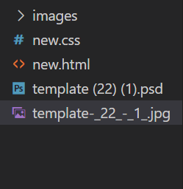

**Result-**: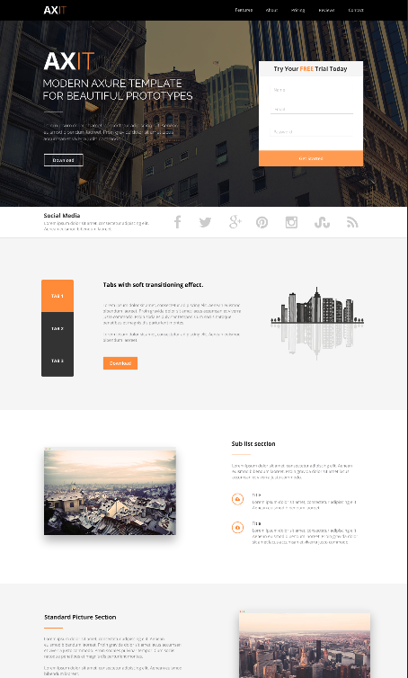

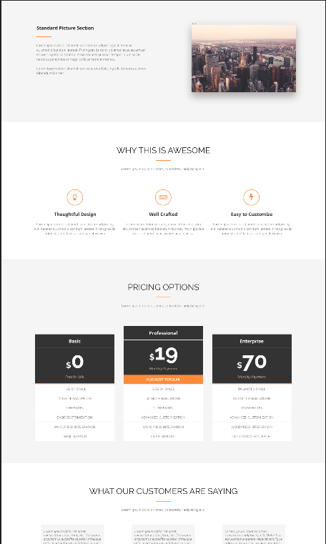

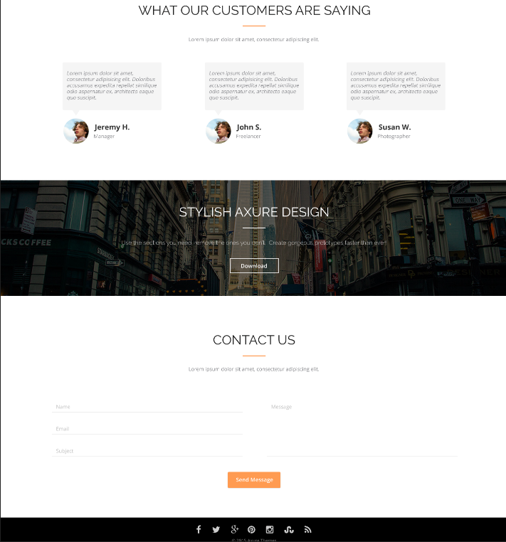

**Website Screenshots** :-

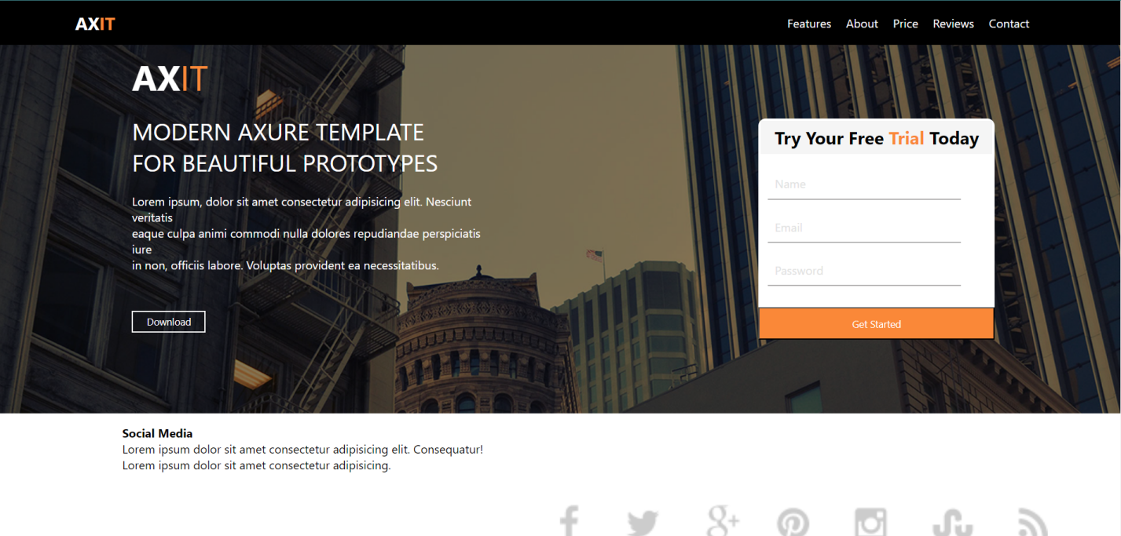

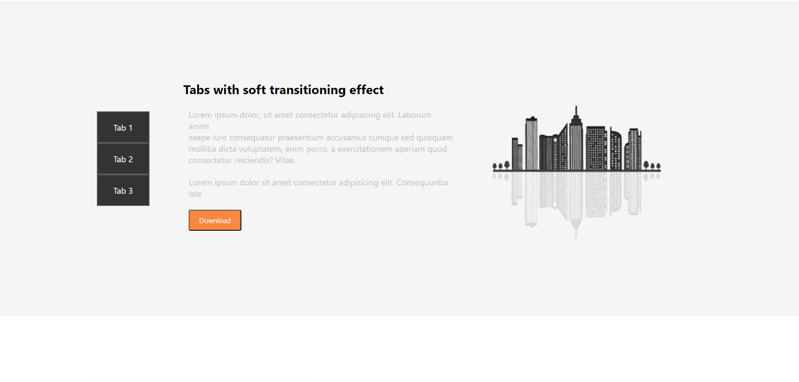

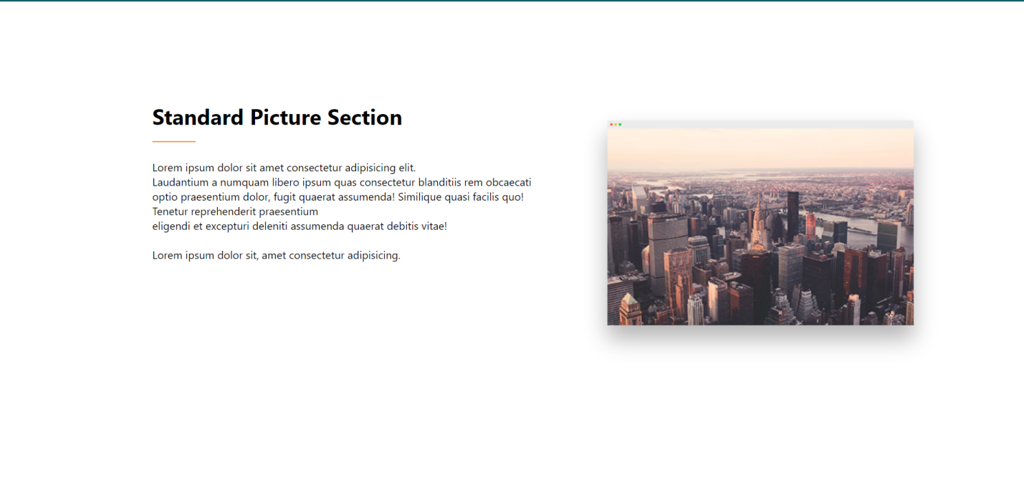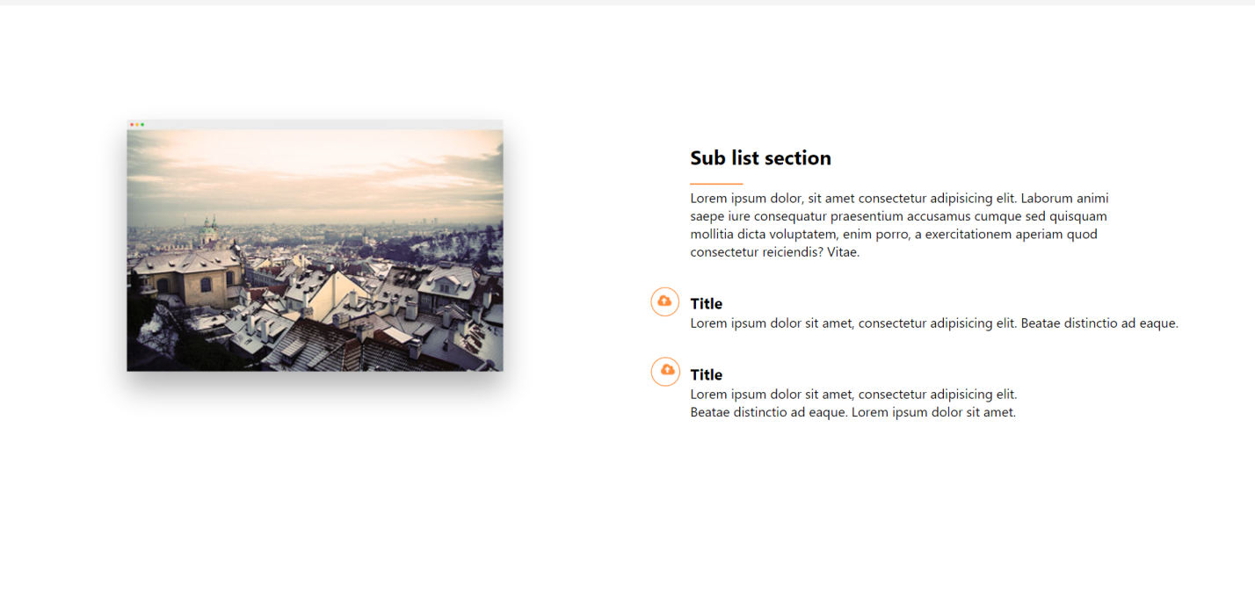

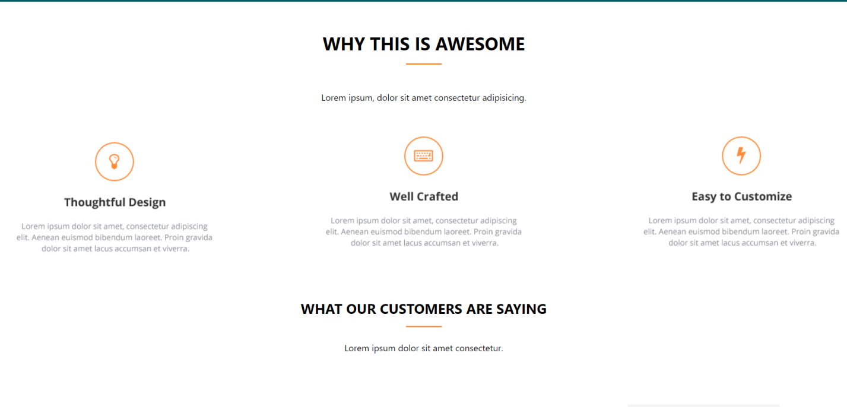

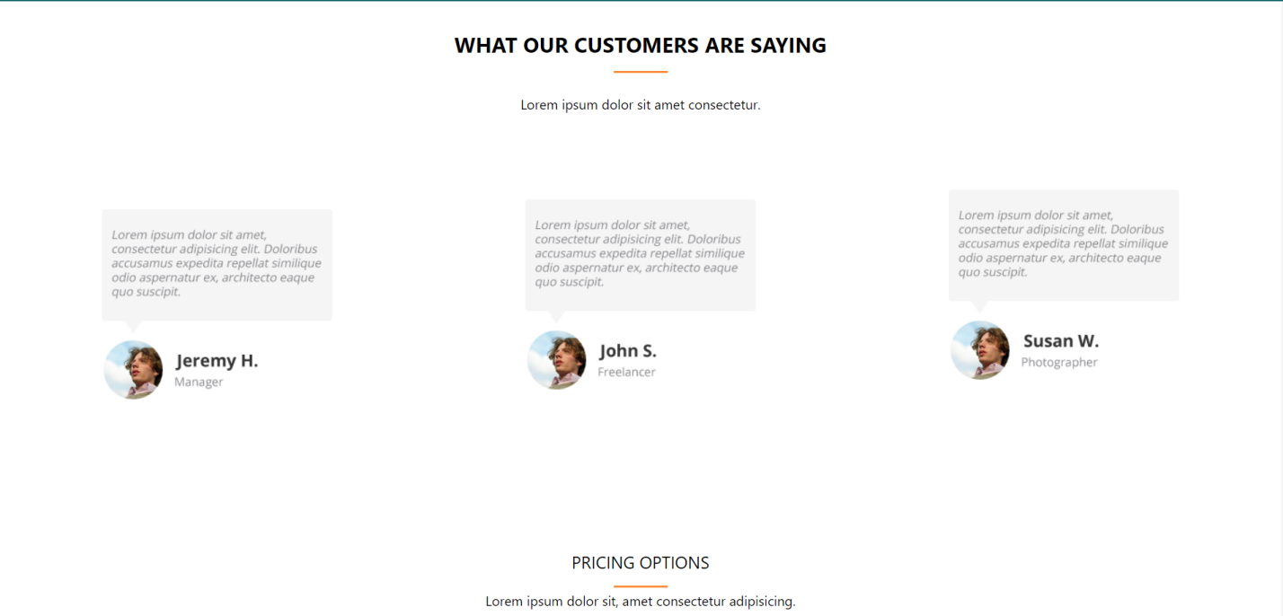

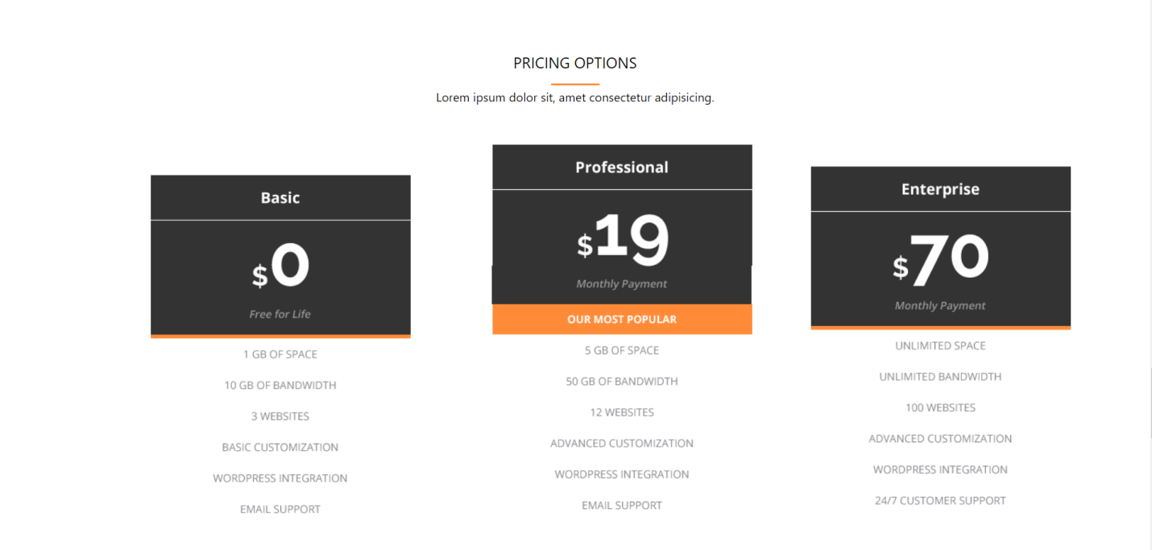

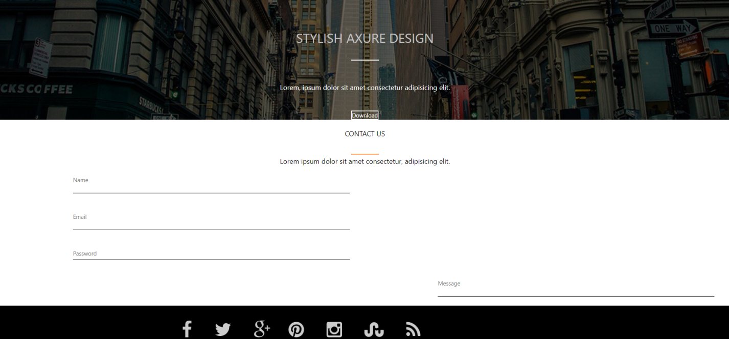

**Mobile View-:**

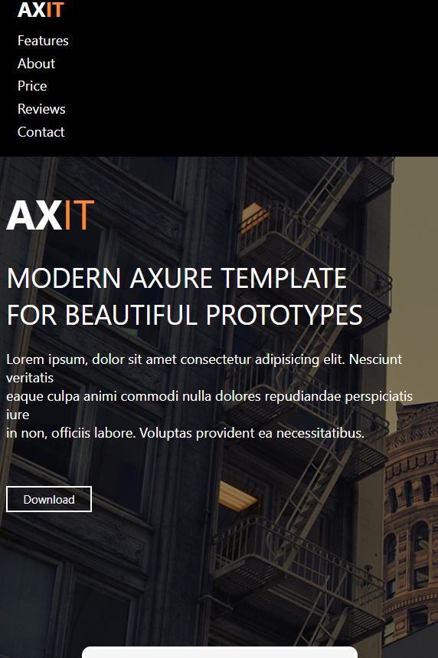

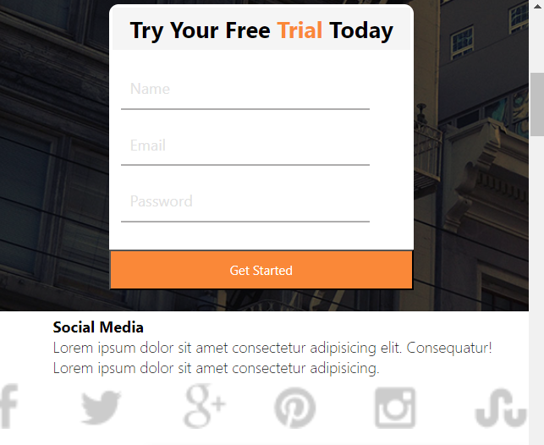

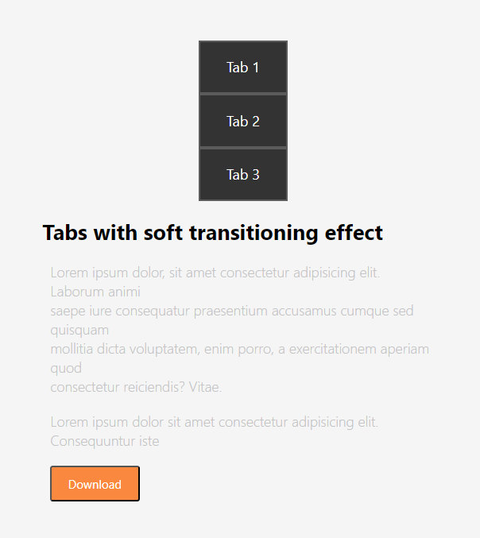

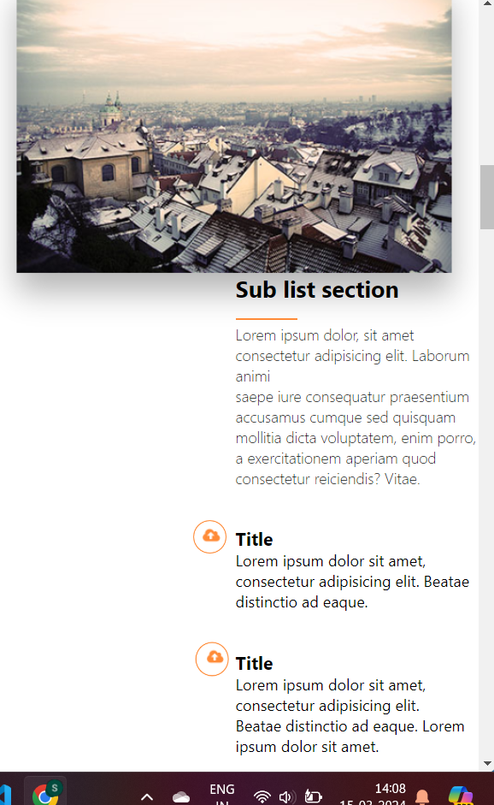

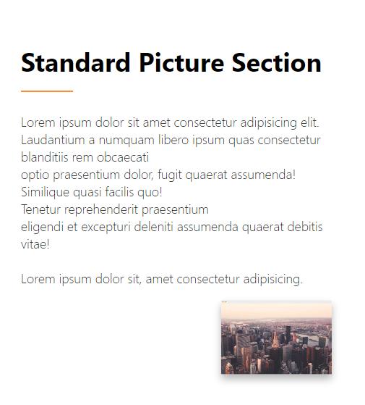

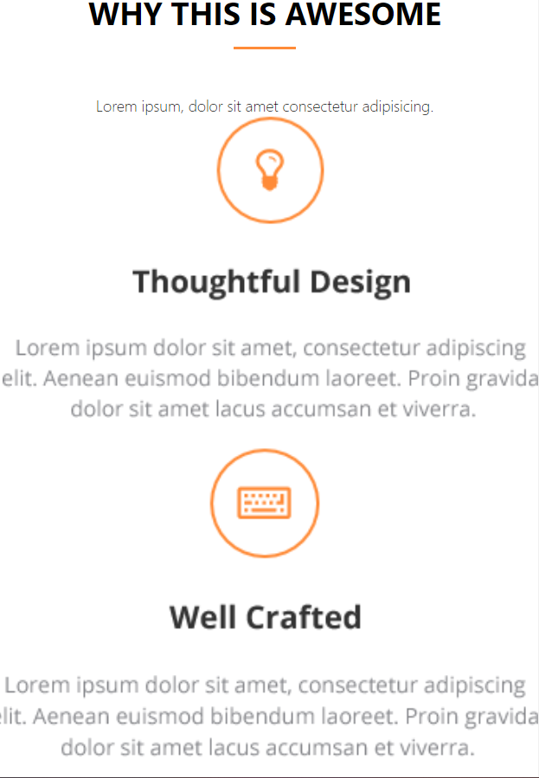

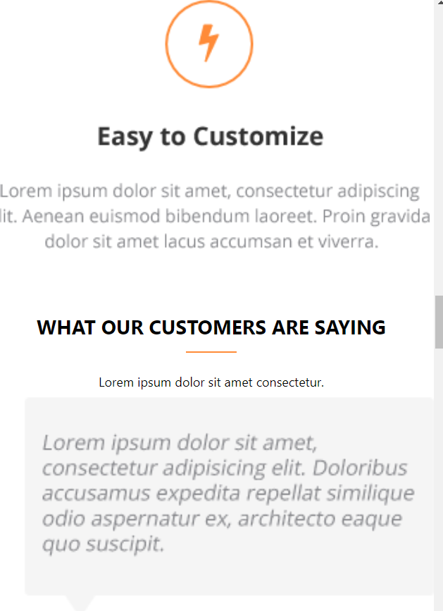



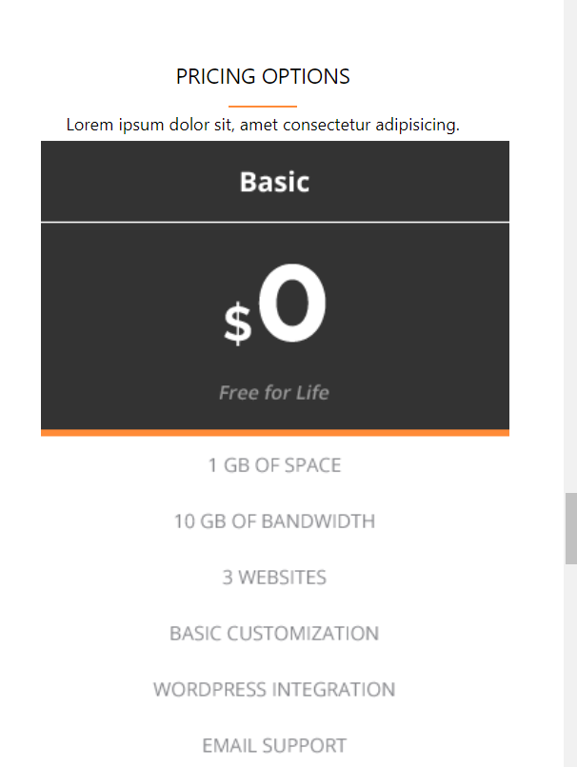



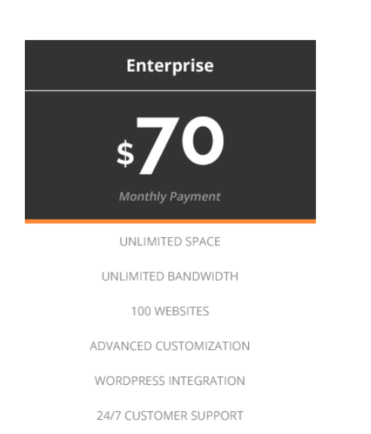

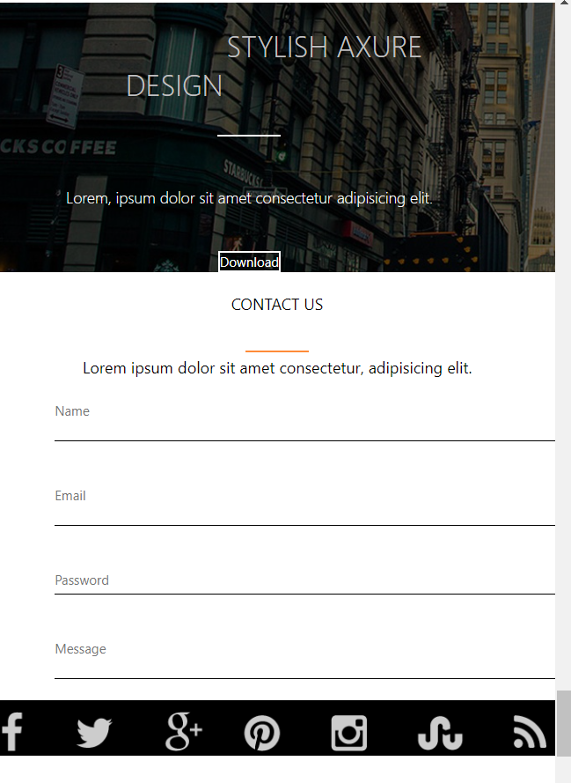

**CODE**

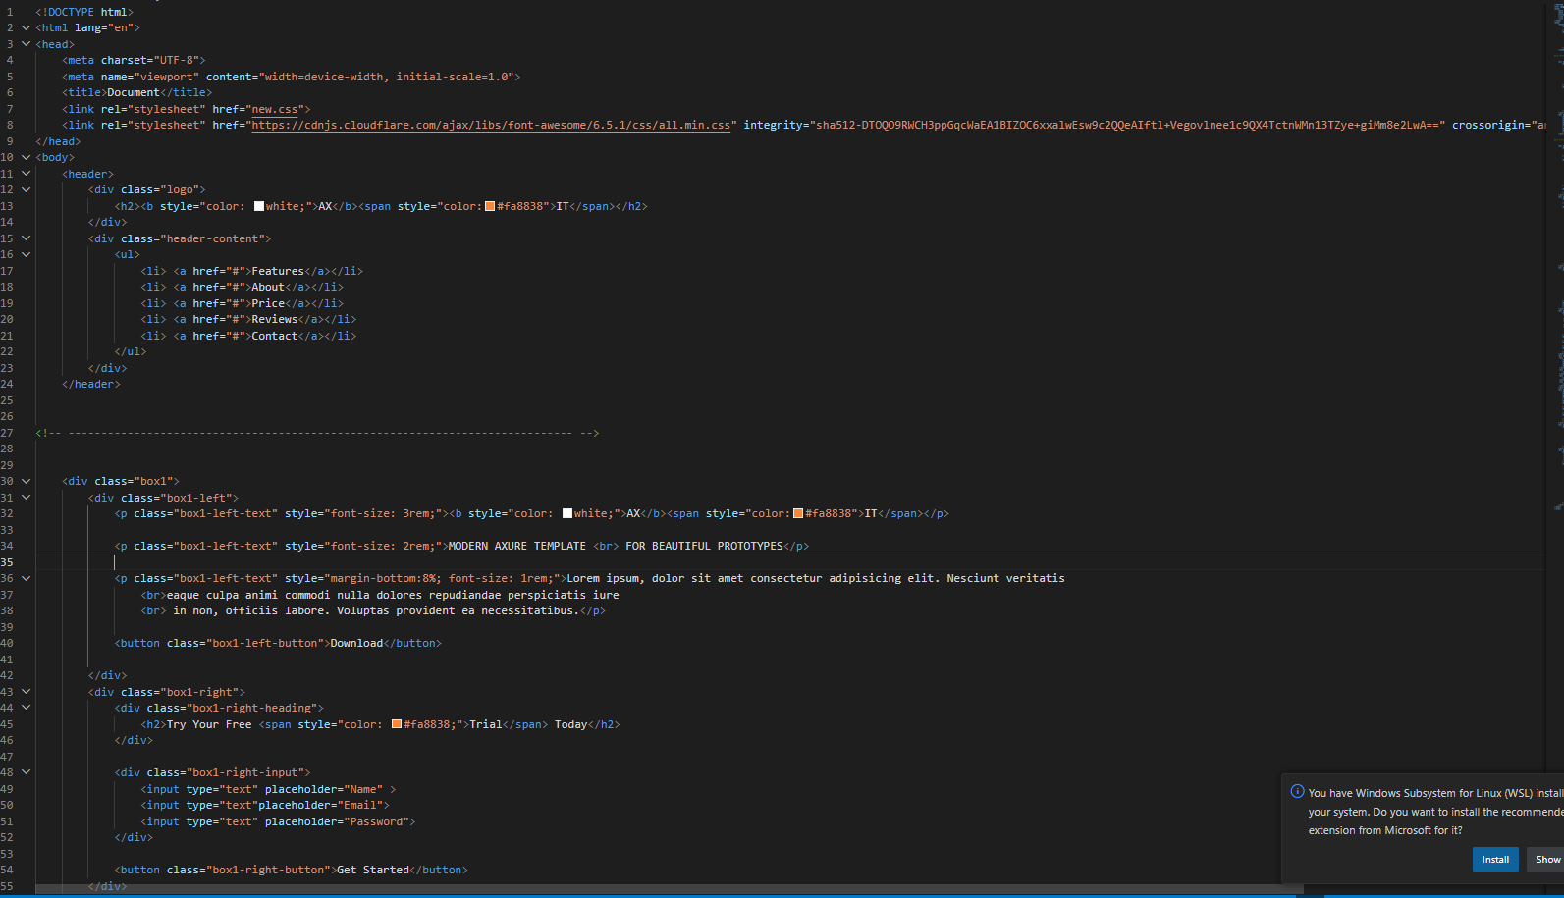

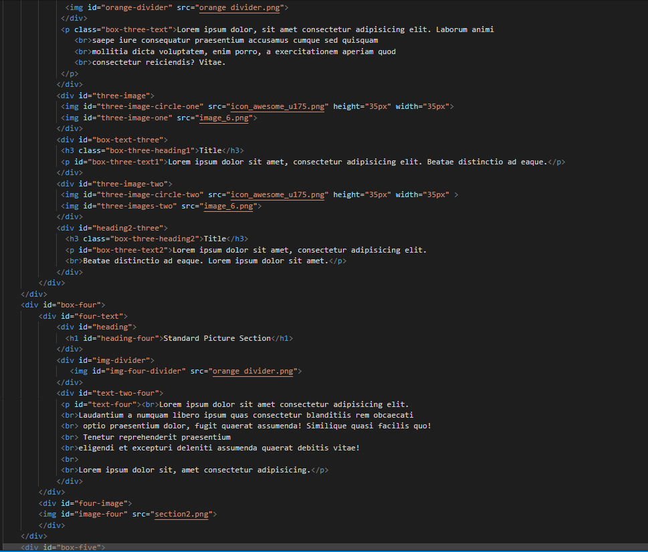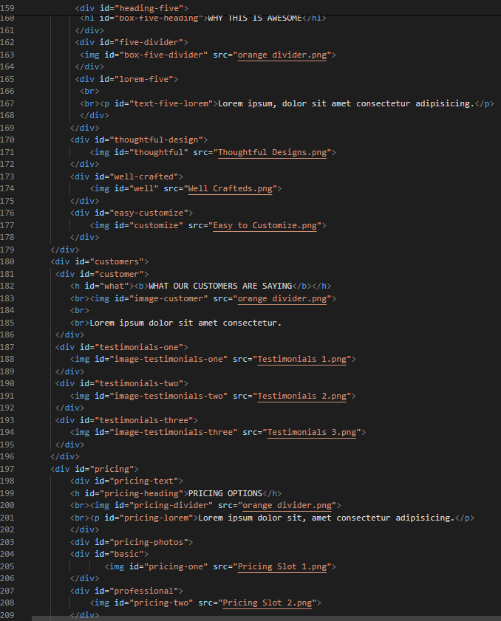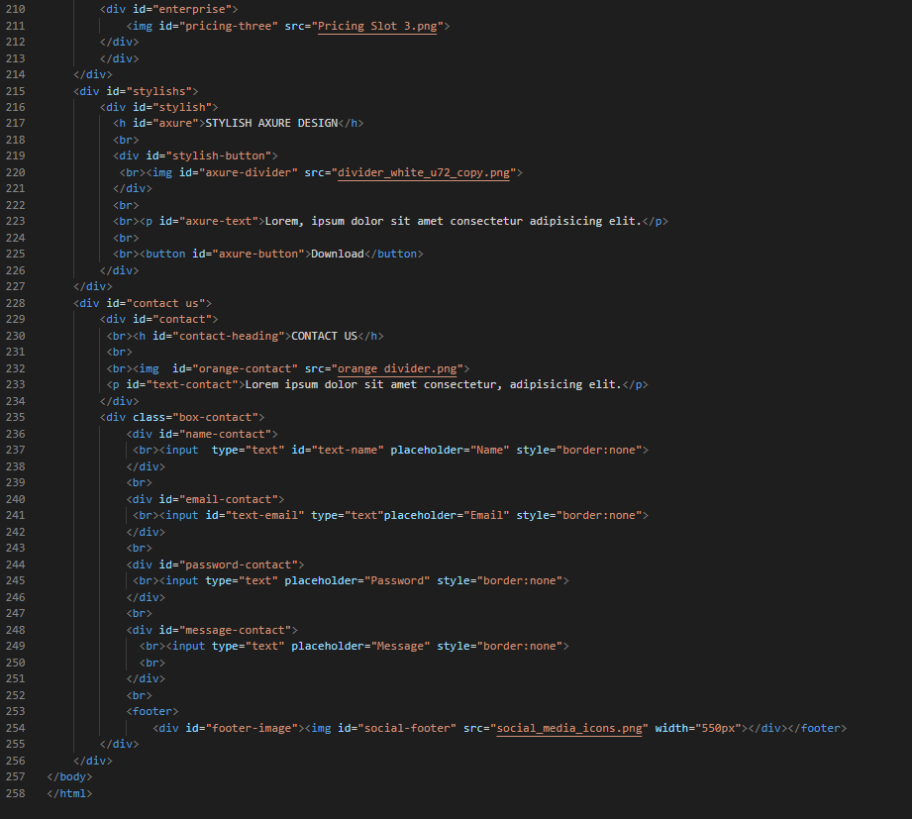

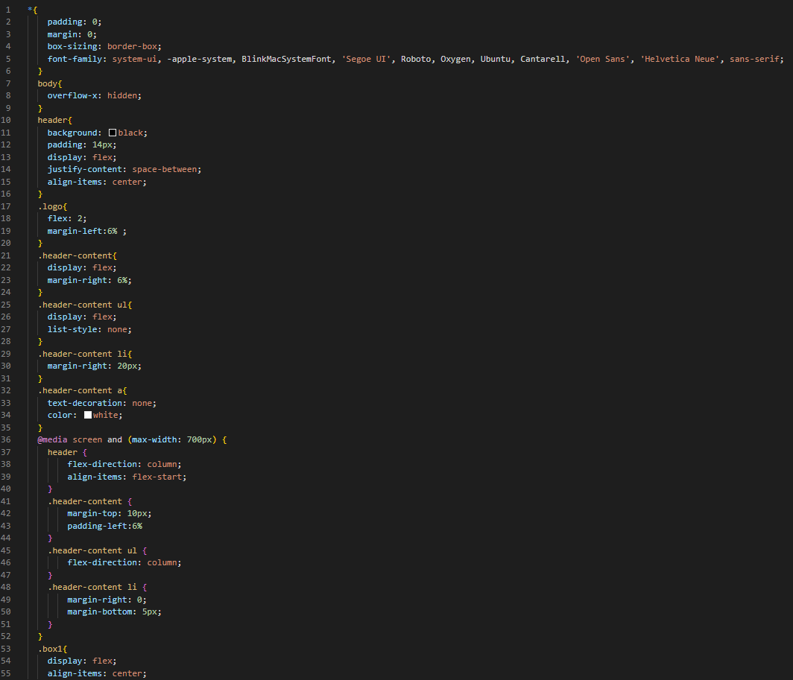

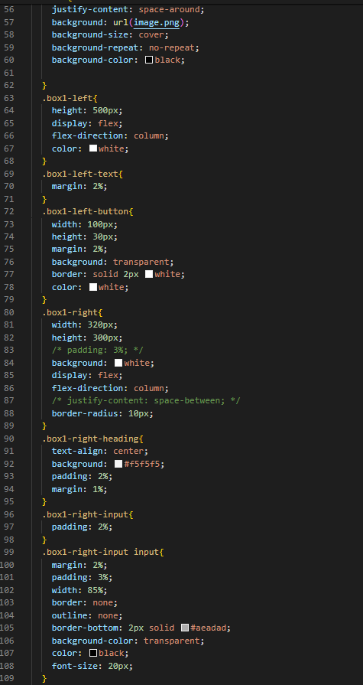

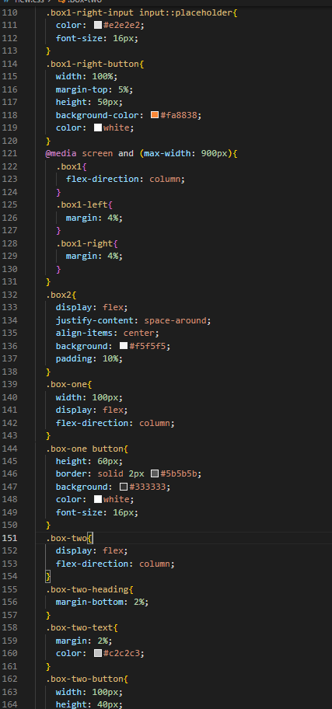

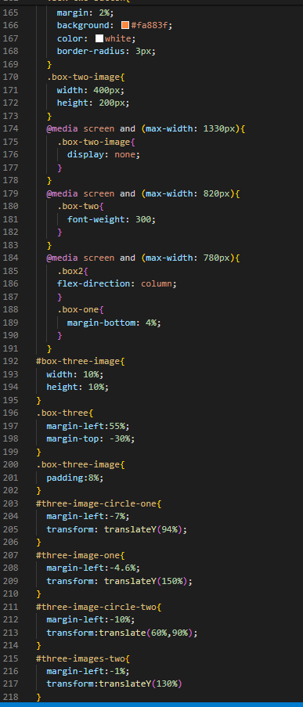

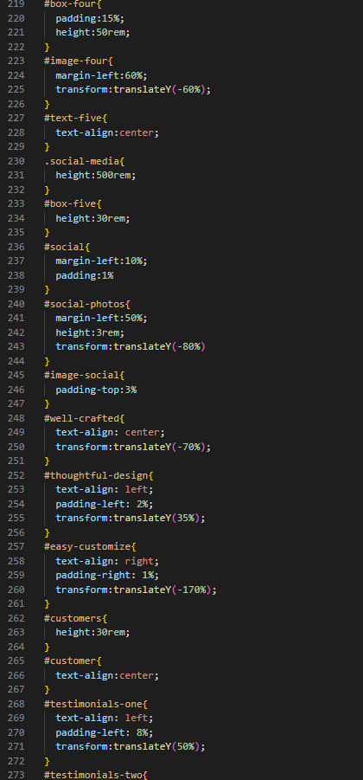

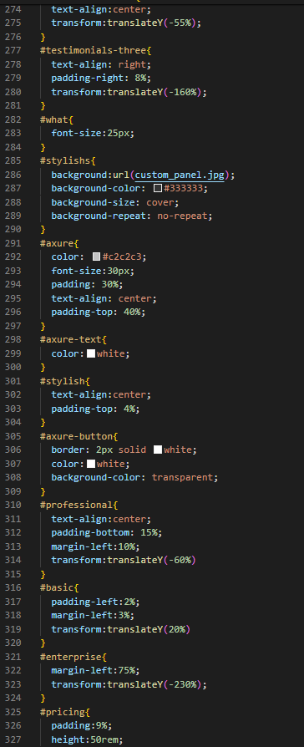

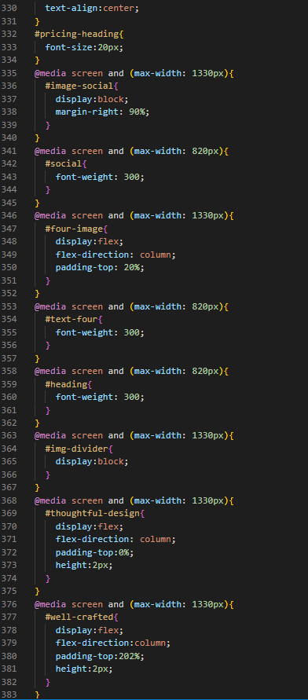

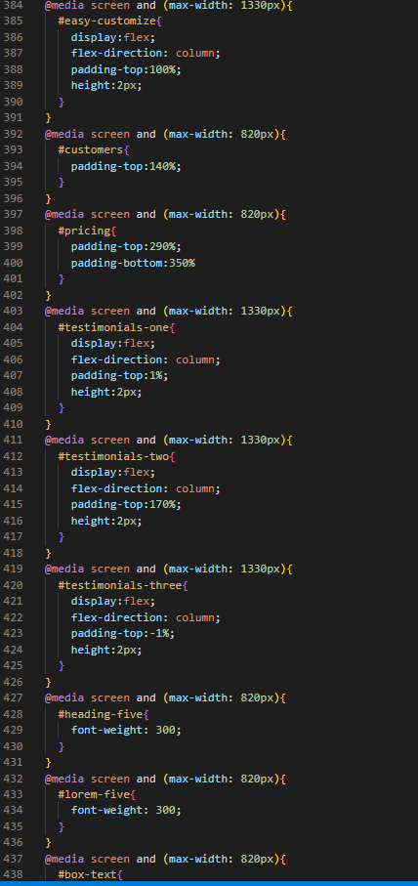

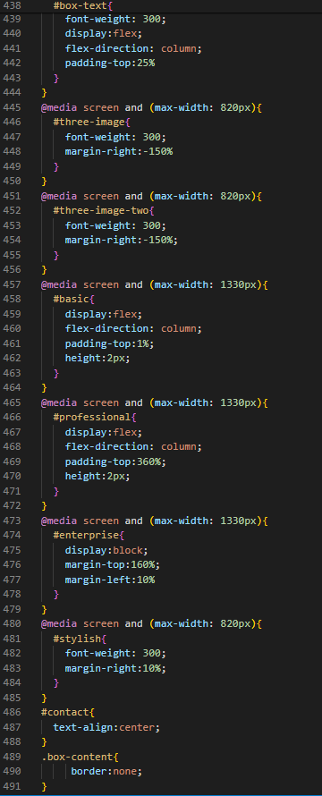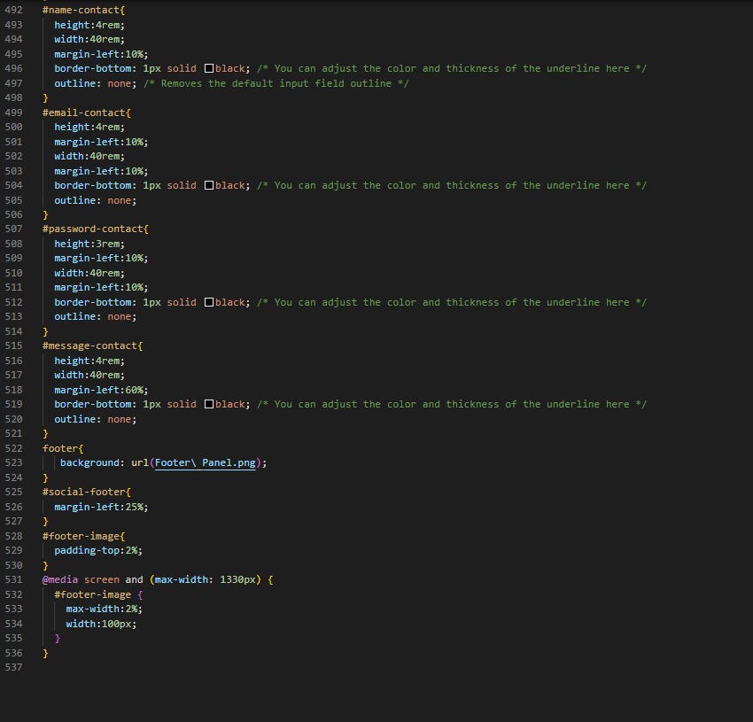

**References**

1. [www.photopea.com](http://www.photopea.com)
2. [www.w3schools.com](http://www.w3schools.com)
3. [www.psdFreebies.com](http://www.psdFreebies.com)
4. <https://fonts.google.com/>